What is the Vmax of an enzyme catalyzed reaction if the Km is 1 mM , the [S] of substrate is 0.25 mM, and the velocity is 0.2 µmol/min?

|  |  |  |
| --- | --- | --- |
|  |  | 0.25 µmol/min |
|  |  | 0.04 µmol/min |
|  |  | 1 µmol/min |
|  |  | 10 µmol/min |
|  |  | cannot be determined without knowing the concentration of enzyme |

Which of the following statements about the "Induced Fit" hypothesis is true?

|  |  |  |
| --- | --- | --- |
|  |  | Binding of a substrate to an enzyme alters the conformation of both the protein and the substrate. |
|  |  | Binding of a substrate to an enzyme alters the conformation of the substrate, allowing it to bind more effectively to the enzyme. |
|  |  | Binding of a substrate to an enzyme alters the conformation of the protein, while the substrate conformation remains unchanged. |
|  |  | A poor substrate is one that is less effective in inducing the formation of the transition state in the enzyme. |

Match the Lineweaver-Burk plot below with its inhibition type.  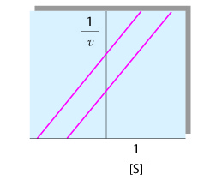

|  |  |  |
| --- | --- | --- |
|  |  | Mixed |
|  |  | Competitive |
|  |  | Uncompetitive |
|  |  | Noncompetitive |

For enzyme catalyzed reactions at high [S], *v* becomes virtually independent of [S] and approaches a maximal limit. This is because:

|  |  |  |
| --- | --- | --- |
|  |  | the rate of side-reactions increases |
|  |  | every enzyme molecule has substrate bound at the active site |
|  |  | unbound substrate molecules block access to the active site |
|  |  | the rate of the back reaction increases |

For a random, single-displacement bisubstrate-biproduct enzyme catalyzed reaction A + B → P + Q, a. either A or B may bind to the enzyme first b. A must bind to the enzyme before B c. the rate limiting step is AEB → PEQ, where E is the enzyme d. P is the product of A and is released last e. P is the product of A and is released before B binds to the enzyme.  Choose the correct answer.

|  |  |  |
| --- | --- | --- |
|  |  | a and e |
|  |  | b and e |
|  |  | b, c and d |
|  |  | a and c |

You determine that a new drug, Tamustatin, increases the Km for the enzyme gigemase but has no effect on Vmax. Conditions for the study were [tamustatin] = 1 × 10-4 M, KI = 1 × 10-5 M. Inhibition of gigemase by tamustatin is:

|  |  |  |
| --- | --- | --- |
|  |  | noncompetitive |
|  |  | mixed |
|  |  | uncompetitive |
|  |  | competitive |

Taking the reciprocal of both sides of the Michaelis-Menten equation yields an equality conforming to the straight line equation y = mx + b where the:

|  |  |  |
| --- | --- | --- |
|  |  | slope = 1/[S] and y-intercept = -1/Vmax |
|  |  | slope = Vmax/Km and y-intercept = -1/Km |
|  |  | slope = Km/Vmax and y-intercept = 1/Vmax |
|  |  | slope = -1/Vmax and y-intercept = -1/Km |

Match the Lineweaver-Burk Plot below with its inhibition type.  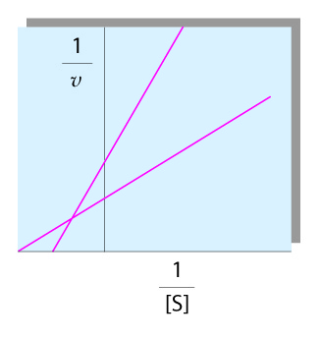

|  |  |  |
| --- | --- | --- |
|  |  | Mixed |
|  |  | Uncompetitive |
|  |  | Noncompetitive |
|  |  | Competitive |

You assay an enzyme catalyzed reaction. With saturated levels of substrate, the reaction velocity is seen to be 0.3 µmol product/min. The enzyme has a molecular weight of 128,000 g/mol, and the tube you used for the assay had 0.1 mL of enzyme in it. The concentration of the enzyme was 0.2 mg/mL. What is the catalytic rate constant (turnover number) for the enzyme?

|  |  |  |
| --- | --- | --- |
|  |  | 0.0005/min |
|  |  | 1920/min |
|  |  | 1.92 × 106/min |
|  |  | 0.3 µmol/min |
|  |  | none of the above |
|  |  |  |

The effect of a catalyst is to:

|  |  |  |
| --- | --- | --- |
|  |  | lower the transition state |
|  |  | lower the free energy of activation |
|  |  | shift the equilibrium position of the reaction towards products |
|  |  | decrease the free energy of the reaction |

For an enzyme obeying Michaelis-Menten kinetics, k1 = 2 × 106 M-1 · sec-1, k-1 = 2 × 102 sec-1, and k2 = 4 × 102 sec-1. What is the catalytic efficiency of the enzyme?

|  |  |  |
| --- | --- | --- |
|  |  | 1.33 × 106 M-1 · sec-1 |
|  |  | 4.0 × 108 M-1 · sec-1 |
|  |  | 7.5 × 10-7 M-1 · sec-1 |
|  |  | 1.0 × 106 M-1 · sec-1 |